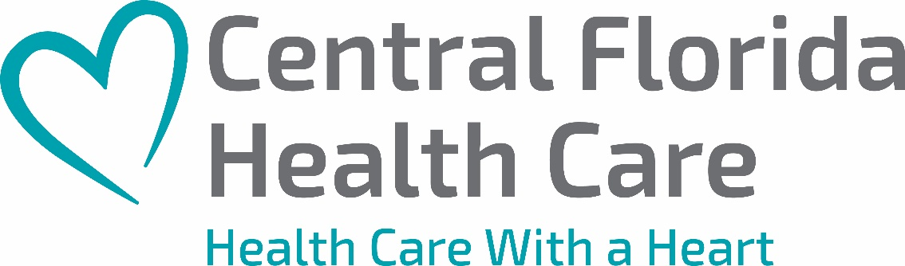

IMMEDIATE RELEASE
June 14, 2021
Sherrie Pratt
Communications Coordinator
(863) 624-8614
spratt@cfhconline.org

Construction Underway on New Medical Facility in Wauchula

Wauchula, Fl – Central Florida Health Care's Wauchula clinic will have a new home later this year. Foundation is down, and construction is officially underway on our new clinic located on South 5th Avenue.

The future stand-alone facility will be state of the art and include medical, adult & pediatric dental, ob-gyn, pediatrics, and pharmaceutical services. We are also excited to announce that this will be the first Central Florida Health Care Clinic with a drive-thru pharmacy. Nearly 50 employees work in our current clinic on KD Revell Road, and they will transfer over to the other location when it opens. It's on target to be ready for patients this December.

Central Florida Health Care serves over 54,000 patients through our 14 locations in Hardee, Highlands, and Polk Counties. We look forward to welcoming patients to the new Wauchula clinic when it opens.

Founded in 1972, Central Florida Health Care is a 501(c)(3) nonprofit organization serving the Polk, Highlands, and Hardee communities. Our goal is simple - to provide high-quality, affordable, and accessible health care services to all, regardless of ability to pay. Our sites offer adult and pediatric primary care, dental care, behavioral health, OB/GYN, lab, X-ray, pharmacy, and optometry services. At the core of all that we do is provide every person an opportunity to experience "healthcare with a heart."

